For the Love of the Game?
By Libby Biersach

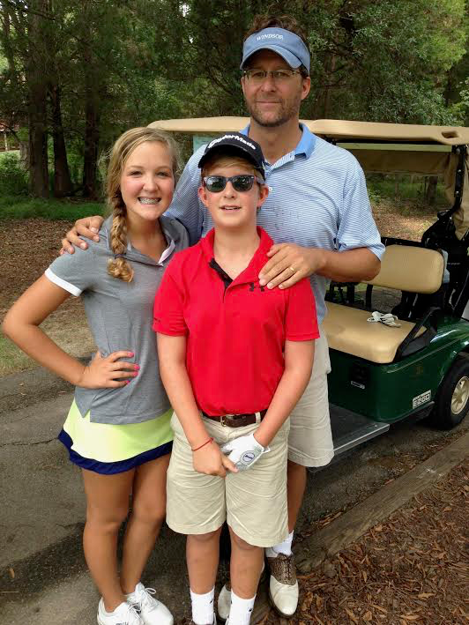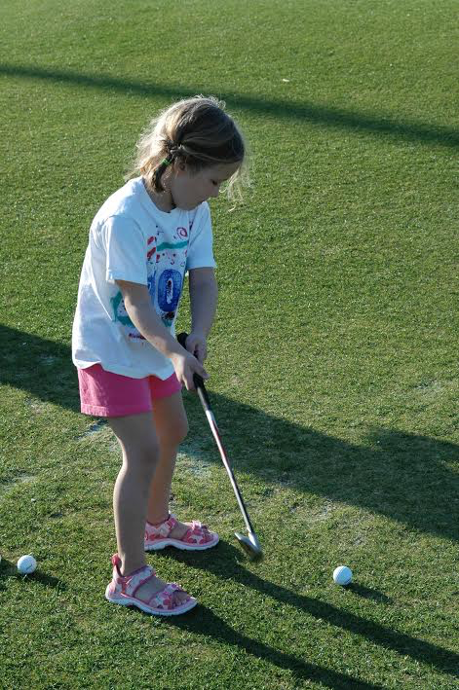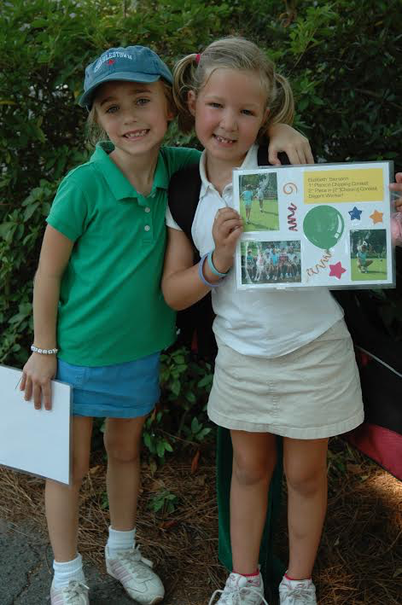
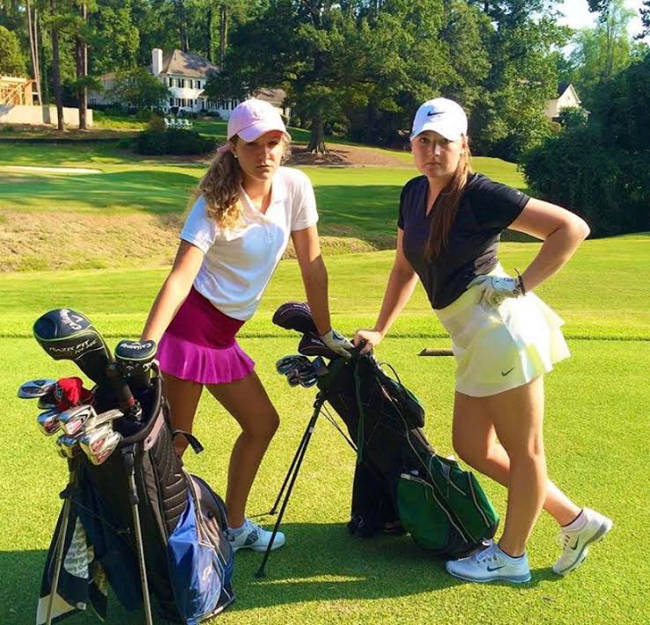
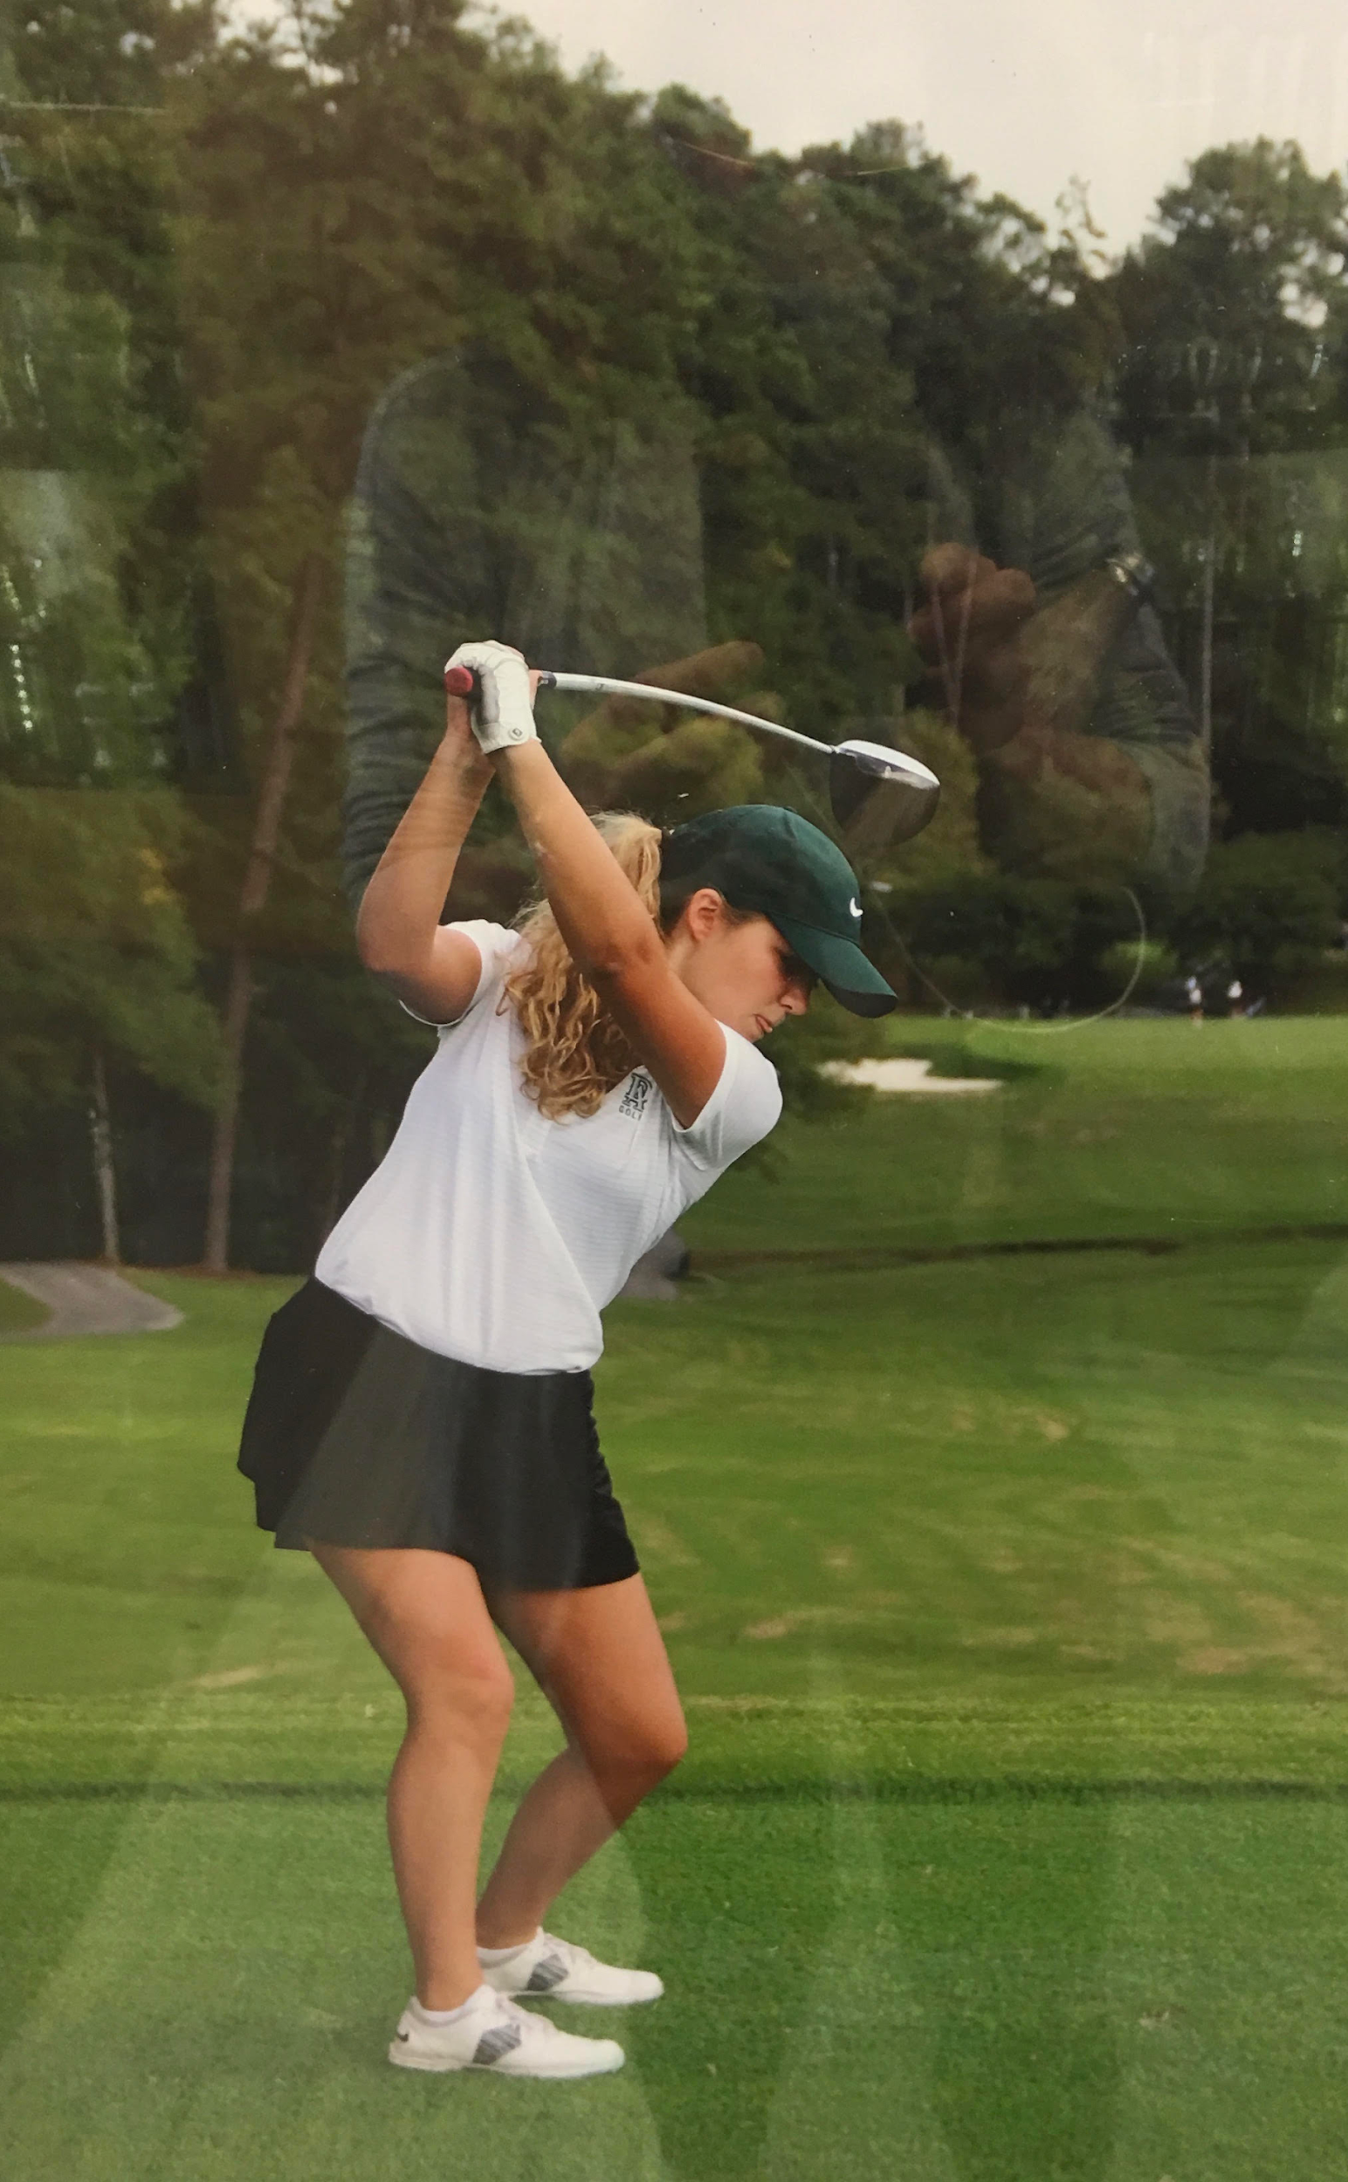
I walked off the soccer field in the middle of a game. What was I supposed to do, they served orange slices as the halftime snack. Gross.

“Biersachs aren’t quitters,” Dad said.

I had to be dragged out of the house for my rec league basketball game. Once again, the snacks were terrible and my uniform was too baggy.

“Biersachs aren’t quitters,” Dad said.

I threw my tennis racket on the court and it bounced back and hit me in the shin. The kids in the clinic always excluded me and there were absolutely no snacks to be had.

“Biersachs aren’t quitters,” Dad said.

From an early age, I was a writer, I was a dancer, I was a social butterfly. I was not an athlete. According to my Dad however, I was the next Annika Sörenstam with promising talent. My status as a “lady duffer” as my family lovingly called me, began at the age of 5. For me, golf wasn’t like the other sports. It was a day with Dad. It was sitting on his lap steering the golf cart. It was flagging down the “cart lady”, eyes wide as I picked out a blue Gatorade and Three Musketeers bar. It was bouncing out of the cart in my hot pink golf skirt, Lily Pulitzer collared shirt, and golden blonde pig tails to wack the ball down the fairway.

From 2005-2008 I attended golf camp after golf camp and had lesson after lesson. What I remember from these experiences isn’t my handicap, or what I shot on 9 holes. I remember licking the cool ranch Dorito dust off my fingers, hiccupping after a sip of Coke. I also remember the awards ceremony. I touted my “Most Improved Golfer” like an Olympic medal.

My dad was so proud of me. He hung my award on the bulletin board in our house for all to see. It still hangs there 14 years later.

I should mention, I never actually loved the game of golf. Despite attending the LPGA, owning a closet full of gear, and my weekly golf outings with dad, Golf bored me to tears. As I grew older, my lack-luster commitment to the game and my ever-growing teenage angst out ruled the desire to please my dad. The snacks lost their appeal too.

Eventually, my dad stopped asking me to play with him. My distance to the sport grew as I fought to distance myself from my parents. I embraced my distaste for sports in general, and I learned how to make my own snacks. I snapped at my dad when he called me by my childhood nickname, Zibby.

Shockingly, by my sophomore year of high school, I was yet again ready to quit another sport. In typical self-centered, teenage fashion, I refused to end my summer at the beach early to join the Varsity Field Hockey team for pre-season. Also, the Varsity halftime snacks weren’t as good as the JV team’s snacks. So I quit.

I fell back into golf out of convenience. My friends were switching to the sport for the last two seasons and I wanted to play a sport for which I could get out of my last period math class early for matches. It also didn’t hurt that playing a round meant chit-chatting with my friends while walking from hole to hole. Not to mention, my school required I play a sport. Golf seemed like an easy option. Surely, I still had my 8-year-old skill.

I didn’t.

My spot on the driving range looked like an excavation site. When I came home from practice each day though, my dad would ask me, “How was golf today little Zibby?” or he would say “You’re a natural on the course little Zibby, I mean you have a beautiful swing.”

Little Zibby. A phrase my dad only uses when he’s proud of me.

I fumbled my way through my Junior and Senior year golf seasons, never placing in matches, never the star player. But I was playing again. My dad and I resumed our Saturday golf outings. The snacks hadn’t lost their appeal after all.

My senior season came to a close and I found myself bringing up the rear in our last match of the season. I wasn’t even a ranked member of the team. As I walked up the hill to the green on the last hole in my high school career, I could see my Dad waiting behind the fence. He was sporting his Wake Forest baseball cap, (I had just gotten in early decision) giving me a huge thumbs up. I must have shot a 60 on 9 holes.

“Let’s go get a snack,” he said.

